Network Security & Scanning Report

Internship Program: Cybersecurity & Ethical Hacking Internship

Company: ApexPlanet Software Pvt. Ltd.

Name: Mhetre Vaishnavi Vinayak

Date: 7/03/2026

Table of Contents

- Introduction
- Objective
- Scope
- Tools & Methodologies Used
- Network Reconnaissance & Host Discovery
- Port Scanning & Service Identification
- Network Traffic Analysis
- Findings & Vulnerability Analysis
- Mitigation Measures & Recommendations
- .Conclusion
- .References

Introduction

Network scanning is an essential process in cybersecurity used to discover devices connected to a network and identify services running on those devices. It helps security professionals detect open ports, active hosts, and potential vulnerabilities that attackers could exploit.
Network scanning plays a major role in network security assessments and penetration testing. By scanning a network, administrators can detect misconfigurations, outdated services, and weak security controls.
In this task, network scanning techniques were used to identify active hosts, open ports, and running services within a network environment.

Objective

The main objectives of this task were:
• To discover active devices in the network
• To identify open ports and running services
• To analyze network traffic
• To detect potential security vulnerabilities
• To recommend security improvements

Scope
The scope of this task includes scanning and analyzing a local system and network environment.
Target Network:
192.168.142.129 (Localhost)
or
Local Area Network (LAN)
The testing was performed in a controlled lab environment using security tools in order to avoid any unauthorized scanning.

Tools & Methodologies Used
Tools Used
1. Nmap
Nmap (Network Mapper) is a powerful open-source tool used for network discovery and security auditing. It is widely used to scan networks and detect open ports and services.
2. Wireshark
Wireshark is a network packet analyzer used to capture and inspect network traffic in real time.
3. Kali Linux
Kali Linux is a penetration testing operating system that includes many cybersecurity tools used for ethical hacking and security analysis.

Methodology
The following methodology was used during the network scanning process:
1. Reconnaissance
Identifying active hosts in the network.
2. Port Scanning
Detecting open ports on the target system.
3. Service Detection
Identifying services running on open ports.
4. Vulnerability Analysis
Analyzing security risks and possible vulnerabilities.

Network Reconnaissance & Host Discovery
Activity:
The first step was discovering active devices in the network.
This process identifies systems that are currently online and reachable.
Command Used:
nmap -sn 192.168.142.1
Explanation:
-sn → Performs a ping scan
It checks which hosts are active in the network.
Output:
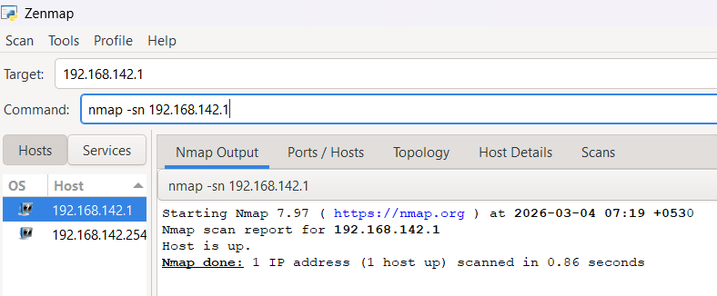
Findings:
The scan identified several active hosts on the network. These hosts were reachable and responding to network requests.

Port Scanning & Service Identification
Activity:
Port scanning was performed on the target IP address to identify open ports and running services.
Command Used:
nmap -sV 192.168.142.128
Explanation:
-sV → Detect service versions
Output:
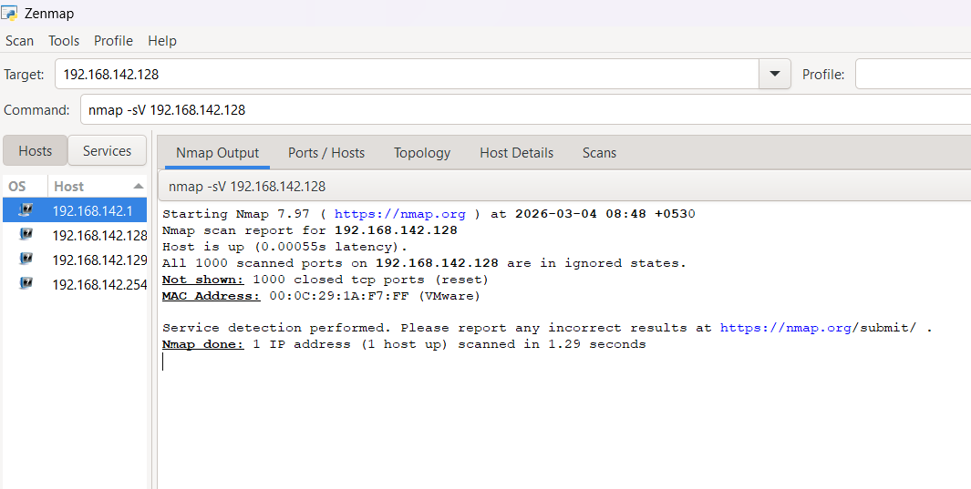
Analysis:
• Port 22 (SSH) – Used for secure remote login
• Port 80 (HTTP) – Used for web server communication
• Port 443 (HTTPS) – Secure web communication
These services allow remote access and web hosting functionality.
If these services are not properly secured, attackers may exploit them.

Network Traffic Analysis (Wireshark)
Activity:Network traffic was captured and analyzed using Wireshark.
Tool Used: Wireshark
Steps Performed:
- Open Wireshark
- Select active network interface
- Start packet capture
- Generate network traffic (ping or browsing)
- Stop capture and analyze packets
Screenshot:
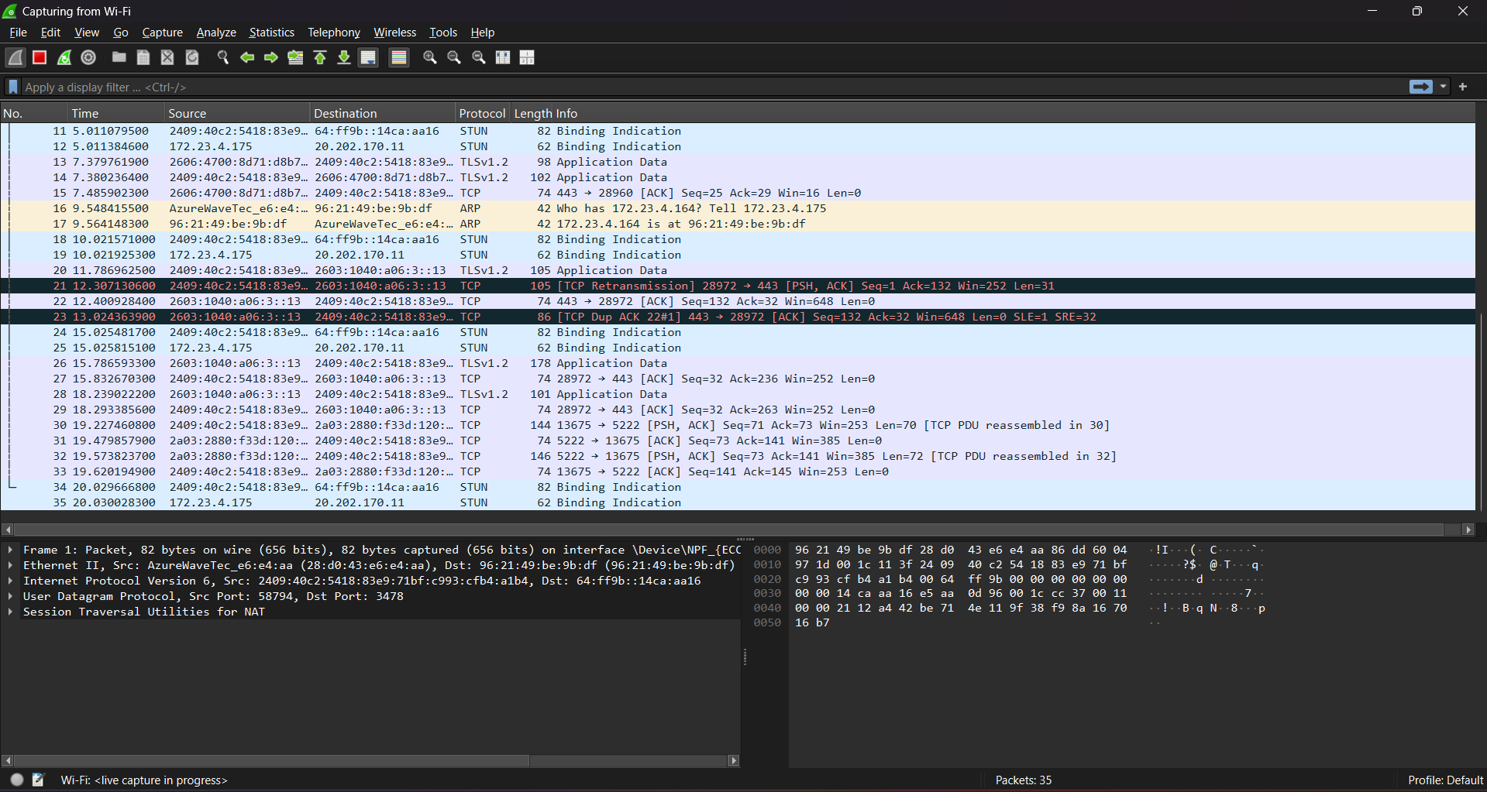
Findings:
The packet analysis revealed:
• Source IP and destination IP addresses
• Protocol types (TCP, DNS, HTTP)
• Packet transmission between systems
No suspicious packets or abnormal traffic patterns were observed during this analysis.
Findings & Vulnerability Analysis
Based on the scanning results, the following vulnerabilities were identified:
Vulnerability 1 – Open Ports
Several ports were found open during the scan.
Example: Port 21 (FTP) – If enabled, it may transmit data in plaintext.
Risk Level: High
Vulnerability 2 – Outdated Services
Some services may be running outdated versions that contain security vulnerabilities.
Example: Apache 2.4.x
Older versions may contain known exploits.
Risk Level: Medium
Vulnerability 3 – Misconfigured Services
Improper service configuration may allow unauthorized access or information leakage.
Example: Unrestricted SSH access.
Risk Level: Medium

Mitigation Measures & Recommendations
To improve network security, the following measures are recommended:
1. Close Unused Ports
Disable unnecessary services to reduce the attack surface.
2. Update Software and Services
Keep all services updated to the latest secure versions to prevent exploitation.
3. Implement Firewall Rules
Configure firewall rules using tools like iptables to restrict unauthorized access.
4. Disable Insecure Protocols
Avoid using insecure protocols such as:
• Telnet
• FTP
Instead use secure alternatives:
• SSH
• SFTP
5. Monitor Network Traffic
Regular monitoring using tools like Wireshark can help detect suspicious activities.

Conclusion
Network scanning is an important practice in cybersecurity for identifying vulnerabilities and securing network infrastructure.
During this task, tools like Nmap and Wireshark were used to perform host discovery, port scanning, and network traffic analysis.
The scanning process successfully identified active hosts, open ports, and running services within the network.
By analyzing these results, potential vulnerabilities were detected and appropriate security recommendations were proposed.
Regular network scanning helps organizations detect security gaps early and strengthen their defense against cyber threats.

References
- Nmap Official Documentation
- Wireshark Official Documentation
- Kali Linux Documentation
- Cybersecurity and Network Security Learning Resources
- OpenVAS Documentation

